ANUGRAHAA V – 2648506
ADT LAB - 6
Simulation of Timestamp Ordering (TO) Concurrency Control Algorithm using Python
Business Domain: Online Shopping System
Aim
To simulate the Timestamp Ordering (TO) Concurrency Control Algorithm in an Online Shopping System where multiple transactions access the same product stock concurrently.
Objectives
- To understand the Timestamp Ordering Protocol.
- To simulate concurrent transaction execution.
- To demonstrate Read and Write operations.
- To observe transaction acceptance and rejection based on timestamps.
Timestamp Ordering (TO) Protocol is a concurrency control mechanism used in Database Management Systems to maintain serializability without using locks.
Each transaction is assigned a unique timestamp when it starts execution.
Each data item maintains two timestamps:
- Read Timestamp (RTS): Largest timestamp of any transaction that successfully read the data.
- Write Timestamp (WTS): Largest timestamp of any transaction that successfully wrote the data.
Whenever a transaction performs a read or write operation, the protocol compares the transaction timestamp with RTS and WTS.
If the operation violates timestamp ordering, the transaction is aborted.
Otherwise, the operation is executed successfully.
Business Scenario
The Online Shopping System stores the available stock of a product.
Suppose two customers simultaneously update the stock after placing orders.
- Transaction T1 represents an older order.
- Transaction T2 represents a newer order.
Timestamp Ordering determines whether each operation is allowed.
Algorithm
- Create one data item (Product Stock).
- Assign initial Read Timestamp and Write Timestamp.
- Create two transactions with logical timestamps.
- Simulate Read operation.
- Simulate Write operation.
- Display the final state.
Data Item Table
Product_ID | Product_Name | Stock | RTS | WTS
P101 | Wireless Mouse | 50 | 0 | 0

Transaction Table
Transaction | Timestamp
T1 | 5
T2 | 10

Create the Data Item Class
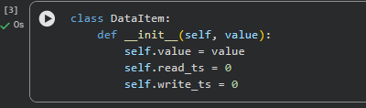
Create Read Operation
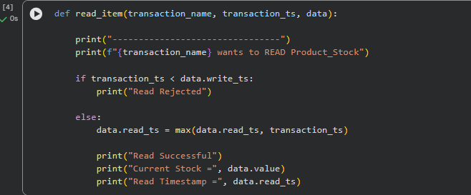
Create Write Operation
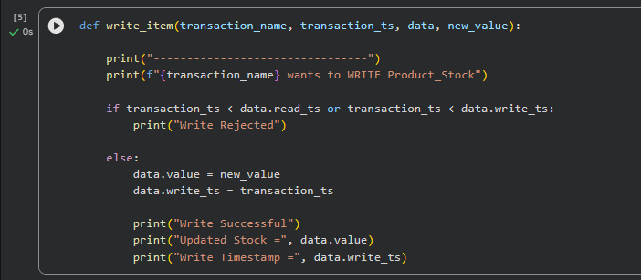
Create the Data Item
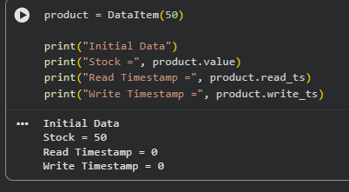
Create Transaction T1
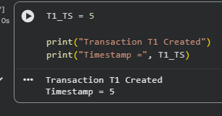
Create Transaction T2
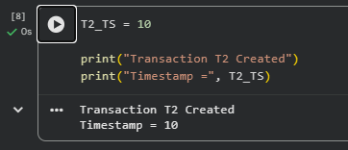

Perform Read Operation for T1
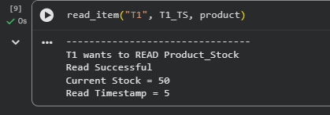
Perform Write Operation for T1
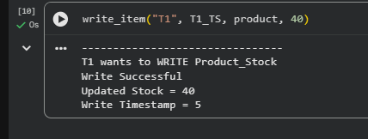
Perform Read Operation for T2
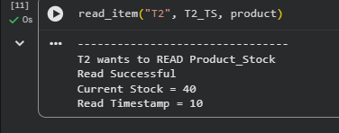
Perform Write Operation for T2
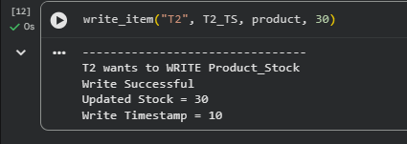
Display Final State
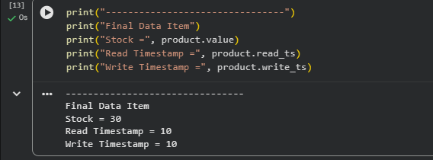

Explanation of Timestamp Ordering Operations
1. Data Item Creation
A data item named Product_Stock is created with an initial stock value of 50 units. Initially, the Read Timestamp (RTS) and Write Timestamp (WTS) are both set to 0, indicating that no transaction has read from or written to the data item.

2. Transaction Creation
Two transactions are created with different logical timestamps.
Transaction | Timestamp
T1 | 5
T2 | 10
Here, T1 is the older transaction with timestamp 5, while T2 is the newer transaction with timestamp 10.

3. Read Operation
Transaction T1
Transaction T1 attempts to read the product stock.
Since the timestamp of T1 (5) is greater than or equal to the current Write Timestamp (0), the read operation is permitted. The stock value 50 is read successfully, and the Read Timestamp is updated from 0 to 5.
Transaction T2
Transaction T2 then attempts to read the same product stock.
Since the timestamp of T2 (10) is greater than or equal to the current Write Timestamp (5), the read operation is also permitted. The stock value 40 is read successfully, and the Read Timestamp is updated from 5 to 10.

4. Write Operation
Transaction T1
Transaction T1 updates the product stock from 50 to 40.
The write operation is allowed because the timestamp of T1 (5) is not less than either the current Read Timestamp (5) or the current Write Timestamp (0). Therefore, the Write Timestamp is updated to 5.
Transaction T2
Transaction T2 then updates the product stock from 40 to 30.
Since the timestamp of T2 (10) is greater than both the current Read Timestamp (10) and the current Write Timestamp (5), the write operation is permitted. The Write Timestamp is updated to 10.

5. Final State
After both transactions are executed successfully, the final state of the data item is shown below.
Data Item | Final Value
Product Stock | 30
Read Timestamp (RTS) | 10
Write Timestamp (WTS) | 10
The final output shows that the latest transaction (T2) successfully updated the product stock. The Timestamp Ordering Protocol maintained the correct execution order of transactions and ensured conflict-serializable execution without using locks.

Result
The Timestamp Ordering (TO) Concurrency Control Algorithm was successfully simulated using Python in the Online Shopping System domain. Two transactions with different logical timestamps performed read and write operations on the same data item. The protocol correctly updated the Read Timestamp (RTS) and Write Timestamp (WTS), ensuring conflict-serializable execution and maintaining data consistency without using locks.

